4.19: 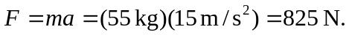 The net forward force on the sprinter is exerted by the blocks. (The sprinter exerts a backward force on the blocks.)

